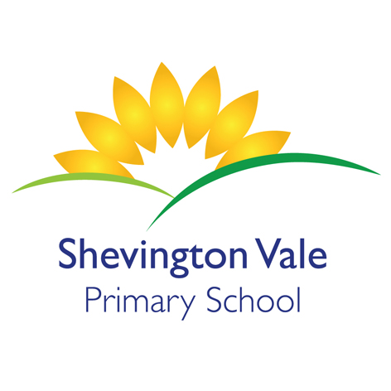

**PSHE Association**

**Relationships**

**What is the same and different about us?**

**Who is special to us?**

Creative

Multiple perspectives

Justify

Debate

Cause + Consequence

Share a Story

Make

Connections

Wider World

Economise

Creative

Multiple perspectives

Justify

Debate

Cause + Consequence

Share a Story

Make

Connections

Wider World

Economise

Creative

Multiple perspectives

Justify

Debate

Cause + Consequence

Share a Story

Make Conne

Wider World

Economise

Creative

Multiple perspectives

Justify

Debate

Cause + Consequence

Share a Story

Make

Connections

Wider World

Economise

Creative

Multiple perspectives

Justify

Debate

Cause + Consequence

Share a Story

Make

Connections

Wider World

Economise

**HISTORY –**

Find out about the life of Guy Fawkes.

Why do we celebrate Bonfire Night? Children to learn about changes beyond living memory that are significant nationally.

To use role play to understand events that led to Guy Fawkes plotting against the King and say how they are feeling in that role.

Children to sequence The Gun Powder Plot.

Children to look at artifacts and discuss which might have been used in the gunpowder plot and give their explanations.

Children to be able to talk about events in the past and present.

To begin to use words like: past, present, future, a long time ago, when I was younger, to show an understanding of the passing of time.

Creative

Multiple perspectives

Justify

Debate

Cause + Consequence

Share a Story

Make Conne

Wider World

Economise

**GEOGRAPHY**

To know what country, they live in and the capital city (link to Guy Fawkes-history and London landmarks)

Create London landmarks with Lego and other construction equipment.

To know what a country is and an ocean

To know the countries and capital cities of the UK

To know what an atlas looks like and what it’s used for.

To locate on maps countries/capital cities of the UK

To use some of the Year 1 vocabulary

Beach, cliff, coast, hill, mountains, rivers, seas, oceans, valley, season, weather, city, town, village, factory, farm, house, office, port, harbor, shop.

**ENGLISH**

What would you paint if you had a magic paintbrush? Why?

Why do you think the emperor wanted more gold?

Do you think it was fair to give just to the poor and not the wealthy?

What happened because of the Emperors greed?

What would you paint and why?

Where is the story set? How do you know?

What does it mean to be poor and wealthy?

**MATHS**

Counting and ordering animals on the farm using correct number formation.

Ordering and sorting farm animals based on different criteria.

Problem solving using addition and subtraction linked to The Little Red Hen.

Making farmyard pictures with 2D shapes and building the farm with 3D interlocking shapes.

Weighing ingredients to make bread and measuring different animals with standard and non standard units.

**The Big Question**: Are all celebrations happy?

**Trip**: Church visit linking to celebrations – Harvest/Christmas

**Guest Speaker**: Visitor to talk about looking after hens

**Class Reader**: The Magic Paintbrush

**RE –**

Following Wigan agreed syllabus and linking in to Christian celebrations in the church.

What does it mean to belong? (First half term)

Children to enquire into and explore the concept of how it feels to belong.

Why do Christians celebrate Christmas? (Second half term)

To enquire into and learn about the celebration of Christmas.



**COMPUTING –**

Text – What are the keys on a keyboard called and what do the important ones do?/Type with both hands.

E-mail – Recognise an e-mail address and contribute to the writing of a class e-mail./Open, read and reply to a class e-mail.

E-safety – What is personal information?/Understand that some online games require real money to buy additional things and you need permission before using it.

Creative

Multiple perspectives

Justify

Debate

Cause + Consequence

Share a Story

Make Conne

Wider World

Economise

Creative

Multiple perspectives

Justify

Debate

Cause + Conse

Share a Story

Make Conne

Wider World

Economise

**DT –**

Children to bake bread and show an awareness of basic hygiene and health and safety when cooking.

Children to measure foods in non-standard measures.

Children to discuss the success of the bread and what worked and what could be changed or improved upon.

Children to understand where the wheat comes from and how the bread is made.

Children to develop a food vocabulary using taste, smell and texture.

Sell the bread in the café and create woven baskets in Art to put them in.

Creative

Multiple perspectives

Justify

Debate

Cause + Consequence

Share a Story

Make Connectio

Wider World

Economise

**SCIENCE –** Materials

Children to create a hen house or egg basket but what material shall we use?

Children will predict and explain why they have chosen their material to build with.

What properties do their materials have? Why is that useful?

What would happen if we used a different material?

Would it be fit for purpose? Why? Why not? How do you know?

Experiment with various materials – understand their properties and what they are used for, in school and the wider world.

Are there any other reasons we use these materials – not only for their properties – what about cost?

**PE**

Coach Mark and the daily mile.

Acquiring and developing skills.

Catch a bean bag.

Throw a small ball underarm using the correct technique.

Zig-zag through a series of markers spaced evenly.

Applying skills and using tactics.

Working together as a team.

**ART –**

Painting

Children to create a painting based on The Magic Paint Brush. Children to go on a journey with their pencil to create shapes. Children to paint the shapes using 3 primary colours and then by creating secondary colours.

Printing

Children to look at different artists that use a variety of printing methods

Children to look at different fireworks and discuss the shapes that they produce

Children to experiment with lots of different objects, man made and natural, to see the marks they produce and produce their own firework print.

**MUSIC/MFL**

Children will listen to songs with familiar tunes.

Children to learn songs and

add actions to the songs they have learnt.

Children to use percussion instruments to accompany songs.

Children to develop symbols for musical notation for the percussion instruments.

Children to improve their singing and performance by recording and evaluating their singing.

Children to perform the songs.

Creative

Multiple perspectives

Justify

Debate

Cause + Conse

Share a Story

Make Conne

Wider World

Economise

Creative

Multiple perspectives

Justify

Debate

Cause + Conse

Share a Story

Make Conne

Wider World

Economise

Creative

Multiple perspectives

Justify

Debate

Cause + Consequence

Share a Story

Make Conne

Wider World

Economise