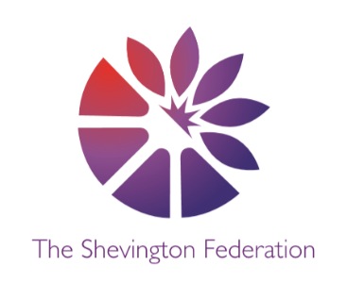4

Year 2 Medium Term Plan – Autumn Term

**The Big Question:** What can we learn from the Great Fire of London?

**Class Trip:** Fire Station

**Class Reader:** The Great Fire of London Book **Significant People:** Samuel Pepys, King Charles II

Y2

014

\\\\\

COMPUTING

**Creating Data – Digital Photography/**

**Programming A – Robot Algorithms**

Students will learn:

* How to take high quality photographs.
* How to decide on landscape or portrait.
* How can lighting can affect a photograph.
* How to give instructions using programming.
* How to design an algorithm.

DESIGN & TECHNOLOGY

**Structures – Castle**

Students will learn:

* How to stabilise and strengthen structures linked to Goldilocks and the Three Bears.
* How to understand Baby Bear’s chair weaknesses and develop an improved solution.
* How to explain why their ideas would be suitable for Baby Bear, before producing a model to hold a teddy.

SCIENCE

**Use of everyday materials**

Students will learn:

* How to identify and compare the suitability of a variety of everyday materials, including wood, metal, plastic, glass, rick, rock, paper and cardboard for particular uses.
* How the shapes of solid objects made from some materials can be changed by squashing, bending, twisting and stretching.

HISTORY

**The Great Fire of London**

Students will learn:

* What London was like at the time of the great fire.
* How the Great Fire of London started.
* How the Great Fire of London was put out.
* How the fire impacted London.
* What changes were made as a result of the Great Fire of London.
* How to create a timeline of the events of the Great Fire of London.
* How we know about the Great Fire of London.
* About other instances of destructive fire.

GEOGRAPHY

**Villages, Towns and Cities part 1**

Students will learn:

* Where the world’s people are.
* What a settlement is.
* What affects where people live.
* How settlements are shaped.
* What makes up a city.
* How cities and villages are different to live in.

**Creative Multiple perspectives Justify Debate Cause + Consequence Share a Story Make Connections Wider World Economise**

MFL

**Spanish**

ENGLISH

Narrative- Adventure: The Building Boy

Poetry- Free Verse: The Moon

Non-Fiction- Diary: The Great Fire of London

Non-Fiction- Malala’s Magic Pencil

2

LEVEL

3

LEVEL

1

LEVEL

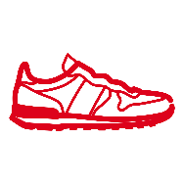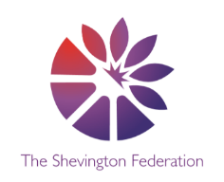

PSHE

**Families and Relationships/ Health and Wellbeing**

Students will learn:

* Families offer stability and love.
* Families are all different.
* How to recognise how others show feelings differently.
* That some friendships might make us feel unhappy and how to deal with this.
* How to describe a range of feelings and develop simple strategies for managing them.
* The benefits of physical activity.
* How to use breathing exercices to relax.

RE

**Creation Story/ Christmas and Chanukah**

Students will learn:

* Why we explore the concept of creation.
* How to enquire into famous creations and inventions and describe what the world would be like if they created it.
* The Bible’s accounts of the creation of the world whilst acknowledging other views about how the world began-such as the Big Bang Theory.
* About ways in which we are harming our world and explore possible solutions.
* The key events of the Christmas Story and the characters within it. Some of the symbols associated with Christmas and their links with the Christmas story.
* About the Jewish festival of Chanukah and enquire into the celebration in the Jewish community today.

**Creative Multiple perspectives Justify Debate Cause + Consequence Share a Story Make Connections Wider World Economise**

PE

**Gymnastics and dance**

Students will learn:

* How to create matching balances with a partner.
* How to roll in different ways while showing control.
* How to jump safely in a variety of ways, on and off apparatus.
* How to combine a selection of moves to create a gymnastics sequence.

MATHS

**Throughout the autumn term, we will be covering the following areas:**

* Place value including decimal places
* Addition and Subtraction
* Multiplication and Division
* Geometry – 2D and 3D shape/Angles
* Fractions, Percentages and Decimals
* Measurement – Length, Perimeter and Mass/Area and Volume

O

LEVEL

G

LEVEL

M

LEVEL

ART

**Expression: Painting and Pastels**

Students will learn:

* How to advance and refine their skills using oil pastels and paint.
* How to draw inspiration and examine the focus artist of Van Gogh, critiquing and discussing his work.
* How to create their own piece of sgraffito art, inspired by the structure and similarity of houses in medieval London.

MUSIC

**Vocal Folk Songs**

Students will learn:

* How to evaluate our stimulus piece of ‘Short Ride in a Fast Machine’ by John Adams.
* How to examine the emotions and feelings that music evoques, aswell as the social background and inpiration behind the work.
* How to use their voices expressively and creatively, changing pitch and rhythm aswell as working on their timing.