
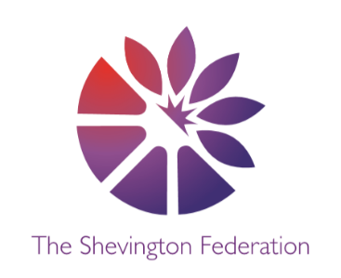
















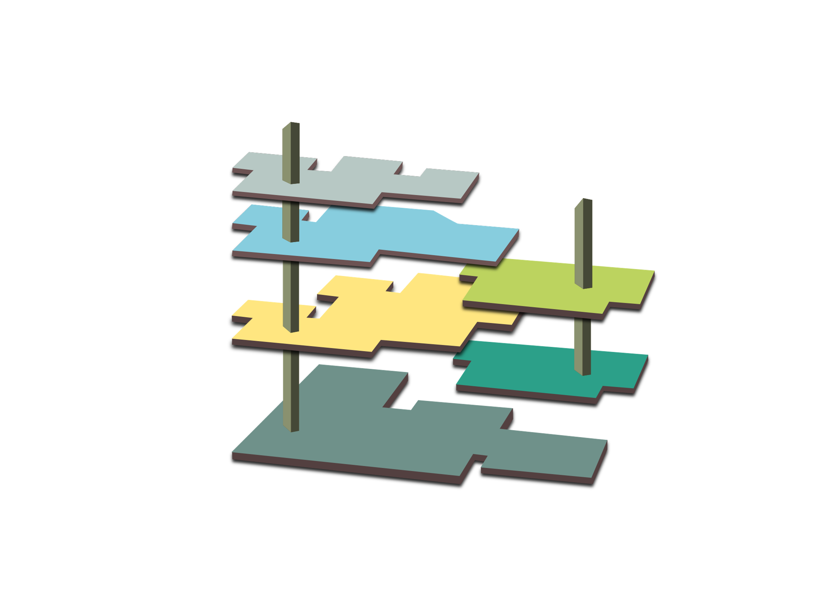
014
Year 2: Museum of Long-Term Knowledge
GROUND LEVEL

The Reflection Room (RE)
- Christianity
- Hindu Dharma and Islam
- Christianity and Judaism

The Room of Wellbeing (PSHE)
- Families and Relationships / Health and Wellbeing
- Economic Wellbeing
- Citizenship/ Changing Body
M
3
LEVEL 3

Around the World (Geography)
- Villages, Towns and Cities Part 1 (Human)
- Villages, Towns and Cities Part 2 (Physical)
- Understanding Brazil

Artefact Collections (History)
- The Great Fire of London
- Monarchy
- Famous Explorers and Adventurers

Significant People (Past & Present)
- Samuel Pepys
- Queen Victoria
- Christopher Columbus

2
LEVEL 2

Global Connections (MFL)
- All About Me (Summer)

The Library (Class Readers)
- The Great Fire of London Book
- Harry Potter and the Philosopher Stone
- Race to the Frozen North

Philosophical Exhibit (Extended Writing)
- What can we learn from the Great Fire of London?
- How are castles still used today?
- Is there anything left to explore?
G
O
OUTSIDE

The Garden (Outdoor Opportunities)
- Local walk observing buildings – comparison between settlements around the world and from history.

Active Space (PE)
- Dance and Gymnastics (Gymnastics-Teacher)
- Invasion Games (Team Games-Teacher)
- Athletics/Striking and Fielding (Team Games-Teacher)
1

LEVEL 1

The Research Lab (Science)
- Uses of Everyday Materials
- Animals Including Humans
- Living Things and Their Habitats

Meet the Maker (DT)
- Structures: Baby Bears Chair
- Textiles: Pouches
- Mechanisms: Making a Moving Monster

Technology Expo (Computing)
- Creating Data – Computing Systems + Networks – IT Around Us / Programming A – Robot Algorithms
- Data and Information: Pictograms
- Creating Media: Digital Music / Programming B – Programming Quizzes
MEZZANINE

The Music Lounge (Music)
- (Ten Pieces) Short Ride in a Fast Machine: Vocal Folk Songs
- Pitched Percussion: Peter and the Wolf
- Pitched Percussion: Pentatonic/ Vocal Call and Response

The Gallery (Art)
- Painting (Van Gogh)
- Drawing & 3D (Hundertwasser)
- Mixed Media (Henri Rousseau and Eric Carle)
L
THE LOBBY

The Gift Shop (Trips & Enrichment)
- Fire Station
- Clitheroe Castle
- Fairy Glen

