Meet Our Staff

Manager: Mrs E Lunt - BA Honours in Primary Education with Qualified Teacher Status/
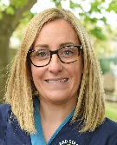
BTEC National Diploma in Early Years
- Lead Safeguarding officer
- Lead SENCo Officer
- Lead Behaviour Officer
- Lead Health and Wellbeing Officer
- Paediatric First aid trained
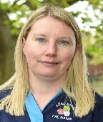
Deputy Manager: Mrs B Ward - Level 4 Early Years Practice
- Deputy Safeguarding officer
- SENCo Support Officer
- Pre-School Language Lead
- Paediatric First aid trained


Practitioner: Mrs G White – Level 3 Early Years DCE Diploma in Childcare and Education
- Paediatric First aid trained

Practitioner: Mrs M Holesinsky - Level 5 foundation degree in children young people and services
- Paediatric First aid trained

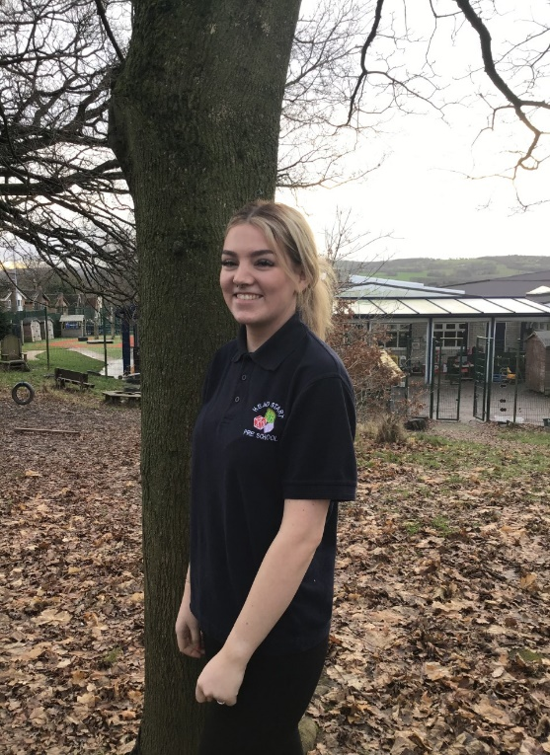
Practitioner: Miss M Fairhurst – Level 3 CASHE Diploma in Childcare and Education (Maternity Leave from January 2026)
- Paediatric first aid trained

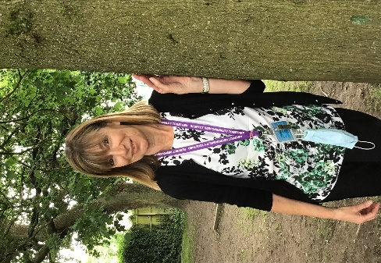
Practitioner: Mrs G Anderson – Level 3 NVQ Early Years and Childcare
- Paediatric first aid trained

Practitioner: Miss Ellie Tolley - BA (Hons) in Learning, Development and Support
BTEC level 3 in child’s play, learning and development.
- Paediatric first aid trained


Practitioner: Miss Layla White – Working towards T level 3 Assisted teaching

Bank Staff: On occasion the setting may use sutibaly qualified staff to cover within the setting.
Students & Volunteers: The setting is privileged to have support from students at; High schools, colleges and Universities from the local area. If you see a new face please feel free to ask who they are!

