Pre-School @ Shevington Vale
Meet Our Staff

Manager: Mrs E Lunt - BA Honours in Primary Education with Qualified Teacher Status/
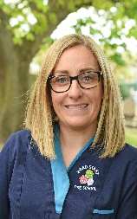
BTEC National Diploma in Early Years
- Lead Safeguarding officer
- Lead SENCo Officer
- Lead Behaviour Officer
- Lead Health and Wellbeing Officer
- Paediatric First aid trained
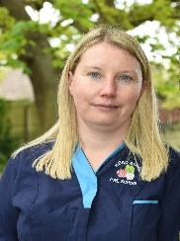
Deputy Manager: Mrs B Ward - Level 4 Early Years Practice
- Deputy Safeguarding officer
- SENCo Support Officer
- Pre-School Language Lead
- Paediatric First aid trained


Practitioner: Mrs G White – Level 3 Early Years DCE Diploma in Childcare and Education
- Paediatric First aid trained
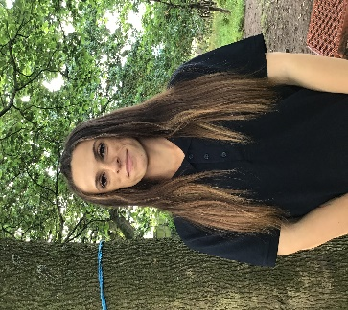
Practitioner: Miss L Davies – Level 3 CASHE Diploma in Childcare and Education
- Paediatric First aid trained

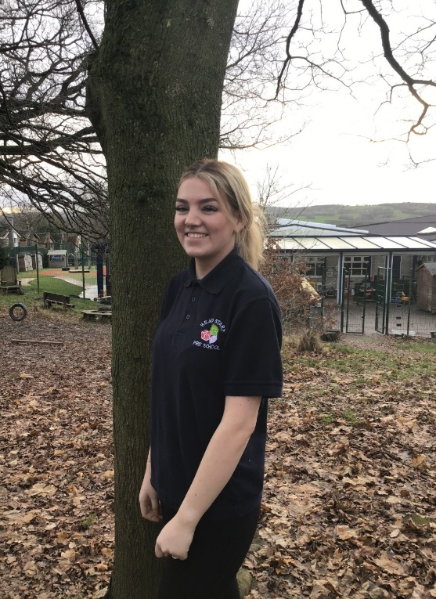
Practitioner: Miss M Fairhurst – Level 3 CASHE Diploma in Childcare and Education
- Paediatric first aid trained

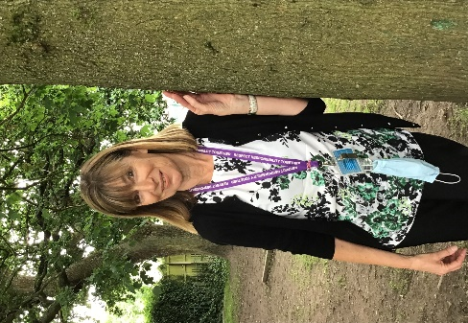
Practitioner: Mrs G Anderson – Level 3 NVQ Early Years and Childcare
- Paediatric first aid trained
Bank Staff: On occasion the setting may use sutibaly qualified staff to cover within the setting.
Students & Volunteers: The setting is privileged to have support from students at; High schools, colleges and Universities from the local area. If you see a new face please feel free to ask who they are!

