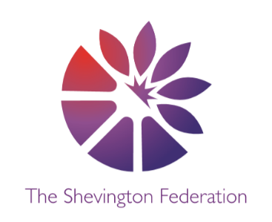
4
Reception Medium Term Plan – Summer Term
The Big Question: What can we learn about the world on our adventures?
Class Trip: Bus Journey
Class Reader: Same, same but Different/ Emma Jane’s Aeroplane/ Coming to England
Significant People: Wilbur and Orville Wright (inventors of the aeroplane)

R
014



\\\\\

Literacy – Reading: word reading

Students will:
- Extend their skill of segmenting and blending, now with longer words CCVC CVCC
- Introduce high frequency words ‘are, was, all, come, to’
- Read sentences aloud, using capital letters, finger spaces and full stops within books to support with this
Personal, Social and Emotional Development

Students will:
- Learn the importance of looking after their wellbeing through exercise, meditation and a balanced diet
- Understand why we have rules
- Understand the importance of perseverance and resilience in the face of challenges, developing confidence in their own ability to solve problems
- Use their developing language and communication skills to work as a team, play co-operatively with others, show an awareness of supporting others and give attention to others, even when engaged in an activity

Literacy – Reading: comprehension

Students will:
- Listen to a daily read linked to our topic and answer comprehension questions, to check understanding
- Participate in independent challenges during provision that require them to demonstrate their understanding of stories we have read, make story maps, recounts and ordering of events

Communication and Language

Students will:
- Use past and present forms accurately to discuss events that have happened or are to happen in the future
- Develop their use of language creatively through rebuilding of stories and developing their own narratives and explanations by connecting ideas and events
- Develop their verbal storytelling as they emerge themselves in a world of adventure and exploration

Literacy – Writing

Students will:
- write their own words, phrases and sentences, using the stories from Drawing Club.
- Understand how and why we use postcards and to create their own, using ‘Grandad’s Island’ as a prompt
- Use capital letters, finger spaces and full stops when forming sentences
- Handwriting sessions, focussing on letter formation
- Write sentences and phrases independently
1
LEVEL
2
LEVEL
Multiple Perspectives Debate Cause, Consequence and Economy Making Connections Wider World Creative Expression



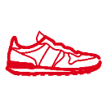









Expressive Arts and Design

Students will:
- Explore how they can make changes to music
- Go for sound walks around the local area
- Continue to participate in sign along sessions and perform sign language they have been llearning at V Festival

Mathematics

Students will:
- Build numbers beyond 10 and verbally count beyond 20
- Add and take away numbers to solve how many are left
- Manipulate, compose and decompose shapes
- Further develop an understanding of sharing and grouping
- Use spacial language to describe what they see from different viewpoints and make simple maps of familiar and imaginary environments

Understanding the World (History & RE – past and present, people, culture and communities)

Students will:
- Discuss how things have changed over time and reflect on this as we travel around the world
- Explore similarities and differences between our lives and the lives of others
- Focus on a particular country, comparing their community, way of life and culture with our own
- Learn about the inventors of the aeroplane and how they have helped people today to explore the world

Physical Development

Students will:
- Focus on control and co-ordination in large and small movements
- Take part in athletics during PE sessions
- Work together and communicate more effectively as a team
- Develop fine and gross motor skills through creating actions for stories
Understanding the World (Science & Geography – the natural world)

Students will:
- Compare a range of environments such as desert, under the sea, rainforest
- Use world map and globe to discover and find new places around the world
- Investigate a range of materials and make predictions about whether an object will float or sink before testing their ideas as part of an experiment
Expressive Arts and Design

Students will:
- Use and explore a variety of materials to design and create a successful boat
- Test and evaluate their boats on water and share their creations, explaining the process they have used
- Explore the use of materials and marks to create a painting inspired by artists Jackson Pollock and Jasper Johns
3
LEVEL
Multiple Perspectives Debate Cause, Consequence and Economy Making Connections Wider World Creative Expression

O
LEVEL
G
LEVEL
M
LEVEL

