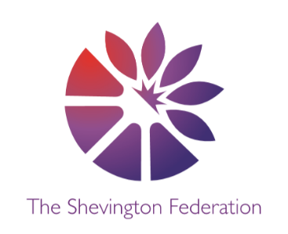
4
Year 2 Medium Term Plan – Spring Term
The Big Question: How are castles still used today?
Class Trip: Clitheroe Castle
Class Reader: Harry Potter and the Philosopher’s Stone Significant People: Elizabeth I, Queen Victoria and Elizabeth II

Y2
014







\\\\\
Multiple Perspectives Debate Creative Expression Making Connections Cause, Consequence and Economy Wider World
DESIGN & TECHNOLOGY
Textiles: Pouches

Students will learn:
- Design a pouch.
- Threading a needle.
- Sewing a running stitch, with evenly spaced, neat, even stitches to join fabric.
- Neatly pinning and cutting fabric using a template.
- Decorating a pouch using fabric glue or running stitch.
SCIENCE
Animals Including Humans

Students will learn:
- That animals, including humans, have offspring which grow into adults.
- About and describe the basic needs of animals, including humans, for survival (water, food and air).
- How to describe the importance for humans of exercise, eating the right amounts of different types of food, and hygiene.

HISTORY
Monarchy

Students will learn:
- Where monarchs have lived past and present.
- Who Elizabeth I was and what life was like in Tudor England.
- Who Queen Victoria was and what life was like in Victorian England.
- Who Elizabeth II was.
- How these monarchs are similar and different.

GEOGRAPHY
Villages, Towns and Cities part 2

Students will learn:
- How to sketch a map of their own settlement.
- How to use symbols and a key in a map.
- How to describe where things are in their settlement.
- How to identify human and physical features in their settlement.

MFL
Spanish
All About Me
Learn & apply:
- Ask/answer “What is your name?” and “My name is…”
- Ask/answer “How are you?” and respond with a range of answers.
- Count up to 10 or 20
- Ask/answer “How old are you?” and “I am x years old…”
- 12 months and say when your birthday is + numbers up to 31
- The alphabet in French/Spanish and be able to spell your name:

COMPUTING
Data and Information – Pictograms

Students will learn:
- To understand what data means and how it can be collected.
- What pictograms are.
- The term ‘attribute’ and use this to help them organise data.
- How to present data in pictograms and block diagrams.
- How to design an algorithm.
ENGLISH

Poetry- The Spider and The Fly
Non-Fiction- This is how we do it
Oracy -We don’t need magic - JK Rowling
Narrative- George and the Dragon
Essay

2
LEVEL
3
LEVEL
1
LEVEL



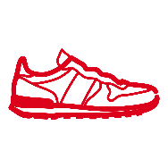
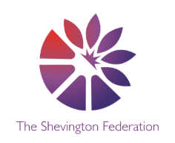


Multiple Perspectives Debate Creative Expression Making Connections Cause, Consequence and Economy Wider World
PSHE
Economic Wellbeing

Students will learn:
- How adults get money.
- How bank account cards work.
- The difference between want and need.
- Ways to develop their skills and talents.

PE
Invasion/Net and Wall Games

Students will learn:

- developing basic ball skills like throwing, catching, and kicking
- understanding how to move safely in a space
- learning to use space to support teammates or make it difficult for opponents

RE
Hindu Dharma/Islam

Students will learn:
- Know that Hindus believe in one God (Brahman) who can be worshipped in many forms.
- Suggest why Hindus might believe that it is important to show devotion to the deities.
- Know that Hindus might worship at a Mandir and/or the home shrine.
- Talk about why Muslims would want to show their gratitude to God.
- Describe the rituals of Islamic prayer (salah), including wudhu and use of a prayer mat.
- Suggest how making time for the five daily prayers is an act of submission.
ART
Drawing & 3D architecture (Hundertwasser)

Students will learn:
- About different architects and explore their work
- Use drawings, notes and explore lines and shapes
- Make an architectural model of a building around a theme of castles
- About structure, form and balance and the way a model looks
- How to use different materials for different architectural purposes

MUSIC
Pitched percussion- Peter and the Wolf

Students will learn:

- The difference between high and low, long and short, fast and slow and LOUD and QUIET and play this on a tuned instrument.
- Know the difference between tuned and un-tuned percussion.
- Follow simple musical instructions and actions.

MATHS

Throughout the spring term, we will be covering the following areas:

- Money
- Multiplication and division
- Measurement- length and height
- Measurement- Mass, capacity and temperature
O
LEVEL
G
LEVEL
M
LEVEL

