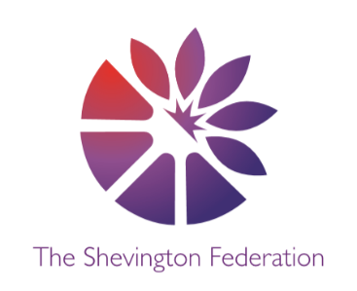
4
Year 2 Medium Term Plan – Summer Term
The Big Question: Is there anything left to explore?
Class Trip: Planetarium – Liverpool World Museum
Class Reader: Race to the Frozen North
Significant People: Christopher Columbus, Matthew Henson and Neil Armstrong

Y2
014







\\\\\
Multiple Perspectives Debate Creative Expression Making Connections Cause, Consequence and Economy Wider World
DESIGN & TECHNOLOGY
Mechanisms – Making a Moving Monster

Students will learn:
- About Levers, linkages and pivots.
- How to analyse popular toys with the correct terminology.
- How to create functional linkages.
- How to design monsters/animals suitable for children, meeting most of the design criteria.
- How to evaluate two designs before deciding on the best one.

SCIENCE
Plants/ Habitats
Students will learn:
- How to observe and describe how seeds and bulbs grow into mature plants.
- How to find out and describe how plants need water, light and suitable temperature to grow and stay healthy.
Students will learn:
- The differences between things that are living, dead and things that have never been alive.
- That most living things live in habitats to which they are suited that provides their basic needs.

MFL

Spanish

ENGLISH

Non-Fiction- Questions and Answers: Neil Armstrong

Narrative- Adventure Story: A lion in Paris

Non-Fiction- Information Text: plants

Essay

HISTORY
Explorers

Students will learn:
- Who Columbus, Henson and Armstrong were.
- What life was like when they were alive.
- How they have contributed to the world.
- Why they are remembered and what they have achieved.
- How to compare these explorers.

GEOGRAPHY
Understanding Brazil

Students will learn:
- Why people visit Brazil.
- What the features of cities in Brazil are.
- How experiences in Rio De Janeiro differ.
- How the weather in Brazil is different to the UK.
- Why the Amazon Rainforest is declining in size.

COMPUTING
Creating Media: Digital Music / Programming B: Programming Quizzes

Students will learn:
- How music makes us feel.
- How to create rhythms and patterns.
- How to create digital music.
- How to use a design.
- How to change a design.
- How to design and create a program.
2
LEVEL
3
LEVEL
1
LEVEL



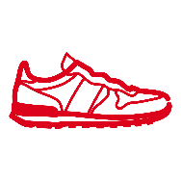
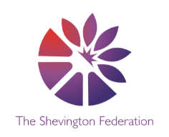


Multiple Perspectives Debate Creative Expression Making Connections Cause, Consequence and Economy Wider World
PSHE
Citizenships / Changing Bodies
Students will learn:
- Know some of the different places where rules apply and why they are in place.
- Know that some rules are made to be followed by everyone and are known as ‘laws’.
- Identify positive and negatives about the school environment and discuss ways of looking after it.
- Know some of the jobs people do to look after the environment in school and the local community.
- Understand how democracy works in school.
- What a secret is and what a surprise is.
- The names of private parts on their body.
- How to stay safe near roads.

PE
Invasion Team Game: A and D

Students will learn:
- How to develop a range of basic game skills and consistency of their replication.
- How to move in your own space in a variety of ways safely using your equipment.
- How to begin to accurately pass the ball in a variety of ways.
- How to perform core skills in a small sided game situation.
- How to keep possession understanding the difference between attack and defence.

RE
Major Muslim Beliefs/ Caring for Others

Students will learn:
- The importance of God in Islam.
- About the religion of Islam and the life of a Muslim believer.
- How to ask questions about the beliefs and practices of Islam.
- How to reflect on some of the qualities of God in Islam.
- How people are special and unique.
- Ways in which they can use their talents to help others.
- About charity in different religious traditions.
- About some famous Christians who put their faith into action.

ART
Mixed Media (Henri Rousseau and Eric Carle)

Students will learn:
- How to form and share ideas relating to Rousseau, using this as a stimulus for their own ideas and imagination.
- How to experiment with colour mixing (e.g secondary colours).
- How to mix colours to represent objects.
- How to look at a range of artists, including Carle, describing differences and similarities between different practices and disciplines and making links to their own work.
- How to use a range of art techniques in colour, texture, line, form, shape and space.
- How to explore the relationship between colour and feelings.

MUSIC
Pitched percussion- Vocal call and response

Students will learn:

- How to explore voices to create descriptive musical effects.
- How to prepare and improve a piece using movement, voice and percussion.

MATHS

Throughout the Summer term, we will be covering the following areas:

- Fractions
- Time
- Statistics
- Position and Direction
O
LEVEL
G
LEVEL
M
LEVEL

