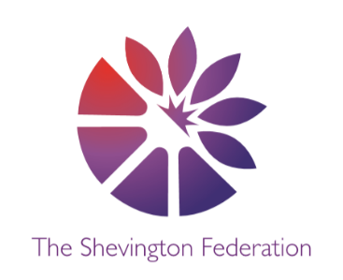

















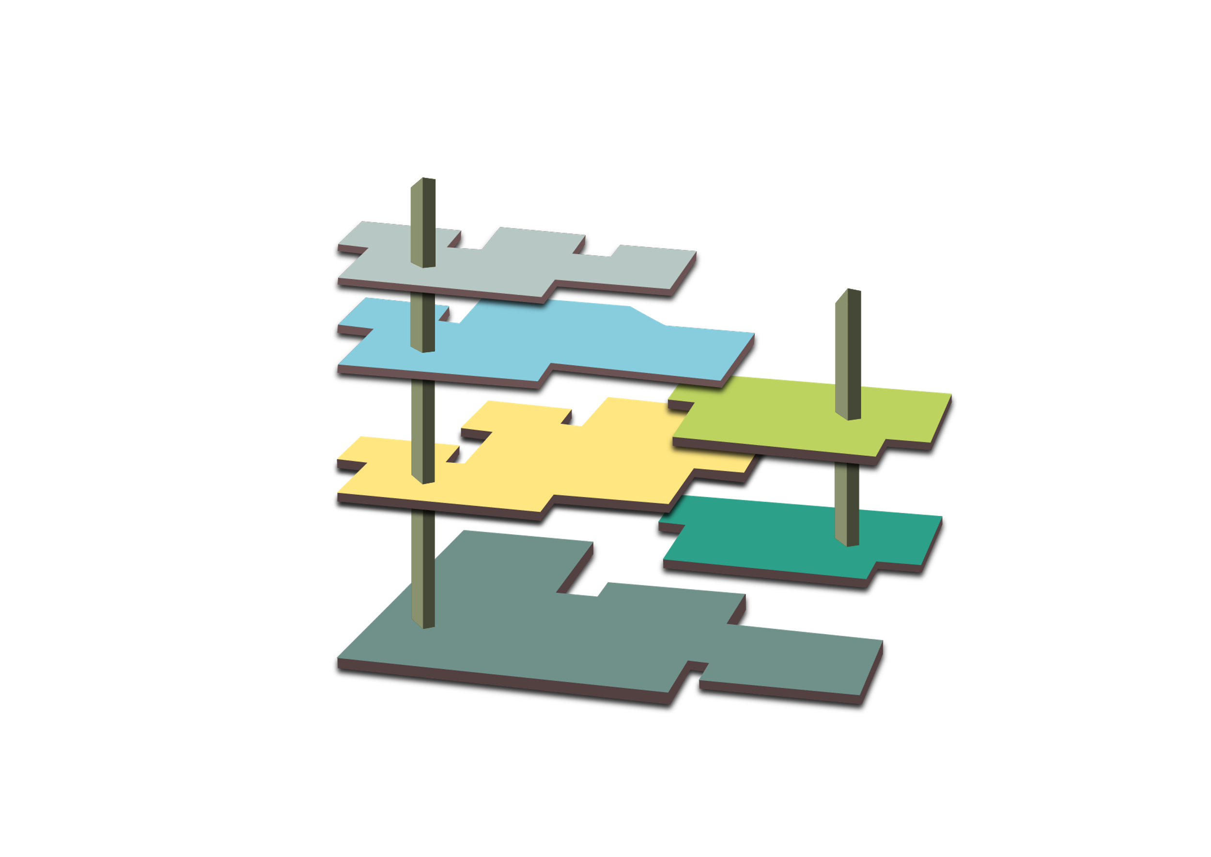
014
L
THE LOBBY
The Gift Shop (Trips & Enrichment)
- Cinema
- Farm
- Post box
- Visits from ‘people who help us’
- Nature walk
- Park visit
- Bee visit - Millbrook
- Whole school trip
- School Transition

GROUND LEVEL

Personal, Social and Emotional

- Making new friendships / developing class rules.
- Helping myself and others and making good choices and being independent.
- Resolving conflict
Communication and Language

- Share special events.
- Follow double/ triple instruction
- Recall stories using a range of resources.

The Dell: Museum of Long-Term Knowledge
M
3
LEVEL 3 –

Understanding the world (humanities – past and present, people culture and communities)
- Share familiar experiences – holidays/ days out.
- Job roles – people who help us.
- Road safety

Understanding the world (science –The natural world)
- Observe natural changes in the environment.
- Life cycles (butterflies and chicks).
- Comparing changes in our natural world.

2
LEVEL 2 –

Literacy
- Traditional stories – story structure and repeated refrains.
- Story prediction and Character discussion.
- Give meaning to marks they make.

G
O

OUTSIDE - Physical Development

The Garden / woodlands (Outdoor Opportunities)
- Explore the woodland – use a range of gross motor skills to climb, balance, swing, scoop and dig.
- Use natural materials to build and create.
- Keeping safe / road safety.

1

LEVEL 1

Numeracy
- Numbers 1-3 / 1-5(recognise, order, compare, less and more than, before and after).
- Dominos and board games.
- Measurement and weight.

MEZZANINE

Expressive Arts and Design
- Use a range of instruments to create music.
- Build and create with a variety of resources.
- Role play – pre-school/ school transitions.

