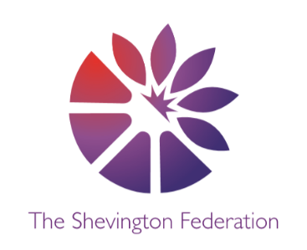
4
Year 1 Medium Term Plan – Summer Term
The Big Question: Do the seasons need to change?
Class Trip: Garden Centre (RHS Bridgewater)
Significant People: The Beatles

Y1
014






ENGLISH

Narrative – The Bear and the Piano by David Litchfield
Poetry – From a Railway Carriage by Robert Louis Stevenson

DESIGN & TECHNOLOGY

Cooking and Nutrition- Fruit and vegetables
Describe fruits and vegetables, and name some places where they grow.
Select fruit for a smoothie and learn how to carefully cut the fruit.
Evaluate the smoothie after tasting it.

HISTORY

Changes Over Time
How have these things changed over time?
- Music
- Communication
- Toys
- Transport

Multiple Perspectives Debate Creative Expression Making Connections Cause, Consequence and Economy Wider World
2
LEVEL
GEOGRAPHY

Oceans and Seas
What is an ocean and where are the world’s oceans?
How deep is the ocean and what lives there?
How is the ocean different at the North Pole and the equator?
Why are our oceans important?

3
LEVEL
COMPUTING

Programming- Programming
animations
Understand how to create a series of images with tiny differences, which when put together will create an animation.

SCIENCE

Plants
Identify and name a variety of common wild
and garden plants, including deciduous and evergreen trees
Identify and describe the basic structure of a variety of common flowering plants, including trees

1
LEVEL



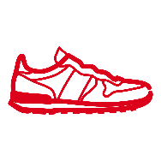
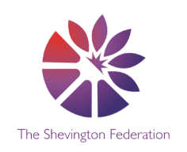


MATHS

Multiplication and Division
Fractions
Position and Direction
Place value within 100
Money
Time

PSHE

Citizenship
Explain why the class and school rules are important.
Discuss the different needs of a range of pets.
Describe some of the needs of babies and young children.
Recognise some similarities and differences between themselves and others.
Identify some groups which they belong to.
Recognise that different individuals belong to different groups.
Explain why voting is a fair way to make a decision involving a lot of people.
Safety and the changing body
Know that they should speak to an adult if they are ever worried or feel uncomfortable. Understand ways to keep safe and not get lost and know the steps to take if they do get lost. Understand that there are hazards in houses and know how to avoid then.
ART

Medium: Handwriting pen, Graphite, Oil pastel, Paper &
Collage
Artists: Eric Carle
Finished Piece- Insect/ plant collage
• That we can use careful looking to help our drawing, and use drawing to help looking.
• That we can use a variety of materials to make images, and that the images we make can become imaginative.
• That we can create individual artwork, and that we can bring that artwork together to make a shared artwork.

PE

Athletics- Begin to develop a range of athletic skills in preparation for Sports Day.

Multi-Skills- develop throwing, catching and balancing skills.

RE

What do Hindu’s believe about God?
Know that Hindu’s believe in one God.

What do people say about God?
Learning about the Christian Church.
O Athletics- Begin to develop a range of athletic skills in preparation for Sports Day.

Multi-Skills- develop throwing, catching and balancing skills.

LEVEL

G
LEVEL
M
LEVEL
MUSIC

Weather- graphic scores
Learn and apply the following musical terms- pulse, tempo and pitch.

Traditional tales
Create musical ideas based on a musical theme for storytelling.

