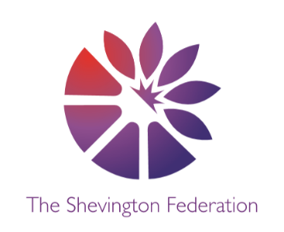
4
Year 5 Medium Term Plan – Summer Term
The Big Question: What defines your culture?
Class Trip: PGL
Class Reader: No Ballet Shoes in Syria by Catherine Bruton | The Queen’s Token by Pamela Oldfield Significant People: Zaha Hadid

Y5
014







\\\\\
DESIGN & TECHNOLOGY

Structures - Bridges

- To understand some different ways to reinforce structures.
- To understand how triangles can be used to reinforce bridges.
- To know that properties are words that describe the form and function of materials.
SCIENCE

Living things and their habitats
- Children will describe how living things are classified into broad groups according to common observable characteristics.
- They will give reasons for classifying plants and animals based on specific characteristics.
Animals including humans
- Children will identify and name the main parts of the human circulatory system
- They will recognise the impact of diet, exercise, drugs and lifestyle on the way their bodies function

MFL

Spanish – Around the Town
Learn and apply
- What type of area you live in – town/ village/ country/ seaside
- Who you live with
- Questions and answers about the methods of transport people take to school
- Typical shops / leisure facilities/ landmarks around a town

ENGLISH

Narrative – The Piano
Non- Fiction – Refugees
Poetry – Sonnet 18 - Shakespeare
Oracy – Elizabeth 1 – Troops at Tilbury
Non-Fiction – A manual for school
Essay – What defines your culture?

GEOGRAPHY

Local Fieldwork

- The children will complete surveys outside local shops gathering information about how far people have travelled
- Children will map how far people have travelled
- They will explore how geographers present their data and create their own surveys and questionnaires

HISTORY

Medieval Monarchs

- Children will look at the struggle for control of the United Kingdom by the ruling monarchs from the battle of Hastings (1066) to the modern day.
- Children will use a range of artefacts, historical accounts and information to develop their understanding of the range of individuals who have ruled over our nation and the impact that each of them has had.

Creative Expression Multiple Perspectives Debate Cause, Consequence + Economy Making Connections Wider World
2
LEVEL
3
LEVEL
COMPUTING

Data and Information – Flat file Database

- Learners will use tools within a database to order and answer questions about data.
- They will create graphs and charts from their data to help solve problems.
- They will also use a real-life database to answer a question, and present their work to others.
1
LEVEL



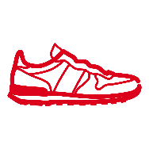
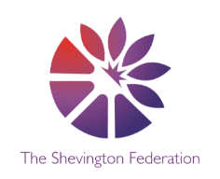


PSHE

Citizenship
- Understand my rights and responsibilities as a citizen of my country.
- Empathise with people in this country whose lives are different to my own.
- Make choices about my own behaviour because I understand how rewards and consequences feel.
- Understand that my actions affect me and others

Safety and the changing body
- Understand what is safe to share online and what to do before sending a message.
- Identify possible dangers online, suggesting ways to stay safe, using the web to research relevant information.
- Accurately name all the relevant parts of the body. They will identify changes they will go through during puberty.
.

RE

Christianity
How do people decide what to believe?
- Raise meaningful questions about things that puzzle them
- Differentiate between questions that can be answered factually and those that have a range of answers, including personal beliefs and values
Judaism
Do people need laws to guide them?
- Pupils will examine how God’s will is revealed to the Jewish people in the Torah.
- They will focus on God, Torah and The Land and The People.
- They will also explore organisation, content and practices associated with the Torah.
- Pupils are encouraged to consider that which guides their life.

PE

Athletics
- Children will identify and show knowledge of some athletic events and techniques;
- They will practise existing basic running, throwing and jumping skills;
- Year 5 will develop their running technique for sprinting, showing some coordination and control;
Striking and fielding
- To throw over and under arm with accuracy, strike and catch a ball, to develop tactics and evaluate success.
ART

3D Architecture
- Children will know architects have a responsibility to design buildings which help make our world a better place, including thinking about the environmental impact of the buildings they design.
- They will make creative choices which both serves ourselves as individuals and the communities we belong to.
- They will use form, structure, materials, and scale to design innovative buildings.

Creative Expression Multiple Perspectives Debate Cause, Consequence + Economy Making Connections Wider World
MATHS

Throughout the autumn term, we will be covering the following areas:

- Shape
- Position and Direction
- Decimals
- Negative Numbers
- Converting units
- Volume

O
LEVEL

LEVEL
M
LEVEL
MUSIC

Ukulele

• Introduction to the ukulele.
• The fretboard and plucking technique.
• Simple chord formation.
• Playing as a chorus of instruments.

