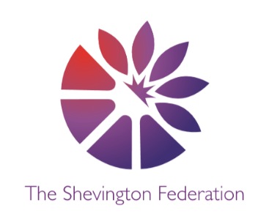4

Year 6 Medium Term Plan – Autumn Term

**The Big Question:** Has the Industrial Revolution had a positive effect on the planet?

**Class Trip:** Formby Beach

**Class Reader:** Kensuke’s Kingdom, Everest **Significant People:** Queen Victoria, Lord Shaftesbury/Charles Darwin, Jane Goodall

Y6

014

\\\\\

MFL

**Spanish**

**Daily Routine - Days Out - Careers**

Children will take part in a simple conversation and express opinions and justifications with accurate pronunciation. Communicate orally linking together several sentences and initiating different themes of conversation. Ask for clarification using a range of phrases. Use phonics knowledge to pronounce a range of unfamiliar language with confidence and accuracy.

ENGLISH

**Narrative:** Children will write a narrative inspired by Kensuke’s Kingdom.

**Poetry:** Children will learn and recite ‘The Chimney Sweeper’.

**Non-Fiction:** Children write a non-fictional report about the history and features of Mount Everest.

**The Big Question**: The final piece of writing will be answering this term Big Question – Has the Industrial Revolution had a positive effect on the planet?

HISTORY

**The Victorians and the Industrial Revolution**

First on the list of historical discovery for Year 6 is the Victorian era - more specifically, the Industrial Revolution. Pupils will be studying the profound impact this period in time had on humanity and the rest of the planet.

From the origins of mass production through to the radical changes that civilization went through by the turn of the 20th Century, we will be studying the effects and cost of progress during this period. As part of this unit, we will be visiting St Helens World of Glass, to experience the terrific – and horrific - stories of the Industrial Revolution for ourselves. Children will see how the mining of coal and advances in glass production shaped the town, both positively and negatively.

**Creative Multiple perspectives Justify Debate Cause + Consequence Share a Story Make Connections Wider World Economise**

2

LEVEL

GEOGRAPHY

**Coastlines**

During this unit, children will study our coastline and highlight important sites such as ports of trade and commercial fishing as well as the people that call coastal towns home. We will also study the coast’s wildlife and how preservation of the UK coastline is more important than ever.

We will be focusing on the effects of costal erosion and use our learning to investigate the coastline of Formby on our school fieldtrip. We will create a report linked to our findings, making use of technical geographical vocabulary learned.

3

LEVEL

COMPUTING

**Systems & Networks: Communication**

This term, Year 6 will be looking at Sir Bernhard Lee’s invention and growth of the World Wide Web and a brief timeline of its development.

They will understand how search engines work and how data is sent across networks.

Children will understand how to responsibly and safely communicate using computing technology.

DESIGN & TECHNOLOGY

**Digital World: Navigation Tool**

Children will design and program a navigation tool to produce a multifunctional device for trekkers using CAD 3D modelling software. They will pitch and explain the product to a guest panel.

SCIENCE

**Adaptation, Inheritance and Evolution**

This term, Year 6 will study adaptation, inheritance and evolution in nature, specifically the peppered moth which underwent a rapid change due to the Industrial Revolution. We will use our knowledge of the period to better understand the reasons for this change and begin to appreciate why this was an important study in understanding and observing evolution.

1

LEVEL

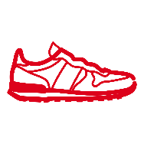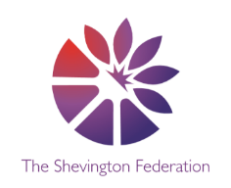

ART

**3D Modelling – Design a Chair**

**Children will learn that artists who create furniture are often called craftspeople or designers. That furniture is more than just practical – designers and craftspeople produce furniture which reflects the era or culture it is made in, or the personality of the maker. They will understand as artists, we can use a variety of materials to design and make our own model chairs. The chairs we make can reflect our personality, and be enjoyed by others.**

**Creative Multiple perspectives Justify Debate Cause + Consequence Share a Story Make Connections Wider World Economise**

PE

**Gymnastics**

During the autumn term, Y6 will be focusing on gymnastics.

PSHE

**Physical Wellbeing**

Children will know to recognise that habits can have both positive and negative effects on a

healthy lifestyle. About how sleep contributes to a healthy lifestyle; routines that support

good quality sleep; the effects of lack of sleep on the body, feelings, behaviour and ability to learn.

RE

**How do Christians mark the ‘turning points’ on the journey of life?**

This unit enables pupils to explore the church as a community of believers and to examine how rites of passage reflect their commitment and relationship with God. The focus is on ‘is life like a journey’ so through this unit students will analyse beliefs, teachings and values and how they are linked by exploring the key sacraments in a Christian’s life.

MATHS

**Throughout the autumn term, we will be covering the following areas:**

* Place value including decimal places
* Addition and Subtraction
* Multiplication and Division
* Geometry – 2D and 3D shape/Angles
* Fractions, Percentages and Decimals
* Measurement – Length, Perimeter and Mass/Area and Volume

O

LEVEL

G

LEVEL

M

LEVEL

MUSIC

**Singing**

We are once again fortunate enough to have Mrs. Holcroft back this year to give the children a fantastic, professional music education.