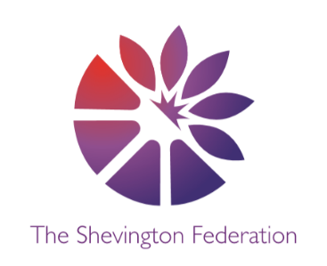
4
Year 6 Medium Term Plan – Summer Term
The Big Question: Do we live in a fair society?
Class Trip: London Residential
Class Reader: Holes, Ruth & The Green Book, Journey to Jo’Burg Significant People: Martin Luther King, Harriet Tubman, Rosa Parkes

Y6
014







\\\\\
SCIENCE

Living Things & Their Habitats. Students will:
- Describe how living things are classified into broad groups
according to common observable characteristics.
- Give reasons for classifying plants and animals based on specific characteristics.
Animals Including Humans. Students will:
- Identify the main parts of the human circulatory system.
- Recognise the impact of diet, exercise, drugs and lifestyle on the way a body functions. Describe how nutrients and water are transported.

COMPUTING

Creating Media: 3D Modelling
- Use Tinkercad to create a 3D model of their design of a navigation tool.
Data & Information - Spreadsheets
- Create a simple excel spreadsheet to help plan the restaurant.

MFL

Spanish: Careers

ENGLISH

Students will:

- Write a non-fiction postcard – fairy tale characters
- Write a persuasive letter for the Restaurant.
- Write Poetry inspired by – Still I Rise by Maya Angelou
- Write a Menu for the Restaurant.
- Essay: Do we live in a fair society?

GEOGRAPHY

Globalisation. Students will:

- Know what globalisation is.
- Think about how globalization has changed the way we communicate.
- Discover what globalisation has to do with fashion and food.
- Discuss where the think globalisation will lead us.

DESIGN & TECHNOLOGY

Cooking and Nutrition: Come Dine with Me (Enterprise Unit)
- Design and create a 3 Course Meal for parents and staff
- Create a theme and branding for the setting
1
LEVEL
2
LEVEL
HISTORY

The Civil Rights Movement. Students will:

- Find out about the Atlantic Slave Trade.
- Discover the reactions of different people to racial segregation.
- Know about the key figures of the Civil Rights Movement.
- Think about the lasting effects of the Civil Rights Movement.

Creative Expression Multiple Perspectives Debate Cause, Consequence & Economy Making Connections Wider World
3
LEVEL



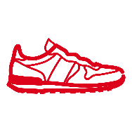
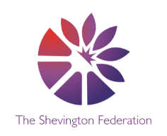


RE

Buddhism - What do we mean by a good life? Students will:
- The Buddha
- The Four Noble Truths
- The Eightfold Path

Christianity - If life is like a journey, what’s the destination? Students will:
- Salvation
- Forgiveness

We will also be looking more in-depth at the holy festival of Diwali – the festival of lights!
ART

Activism: Drawing, Paper, Pen & Paint

- See how artists use their skills to make art which speaks about things that matter, often on behalf of whole communities.
- Create visuals and text which communicate the things that I care about.
- Use line, shape and colour to make my artwork.
- Use typography to make my messages stand out.
- Combine different techniques such as print, collage and drawing.

PSHE

- Economic wellbeing.

- Safety and the Changing body

- Debt Aware – Money Matters

MUSIC

- Song Writing

- Ukuleles

Creative Expression Multiple Perspectives Debate Cause, Consequence & Economy Making Connections Wider World

PE

Athletics
- Athletics
- Striking & Fielding
- Outdoors Adventure

MATHS

Throughout the summer term, we will be covering the following areas:

- Position & Direction
- Statistics
- Geometry
- Enterprise
O
LEVEL
G
LEVEL
M
LEVEL

