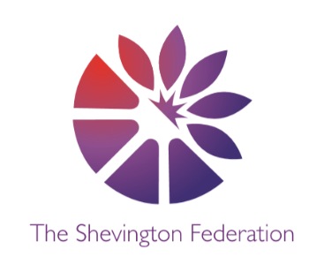4

Year 6 Medium Term Plan – Summer Term

**The Big Question:** Do we live in a fair society?

**Class Trip:** Residential

**Class Reader:** Holes, Ruth & The Green Book, Journey to Jo’Burg **Significant People:** Martin Luther King, Harriet Tubman, Rosa Parkes

Y6

014

\\\\\

SCIENCE

**Living Things & Their Habitats. Students will:**

* Describe how living things are classified into broad groups

according to common observable characteristics.

* Give reasons for classifying plants and animals based on specific characteristics.

**Animals Including Humans. Students will:**

* Identify the main parts of the human circulatory system.
* Recognise the impact of diet, exercise, drugs and lifestyle on the way a body functions. Describe how nutrients and water are transported.

COMPUTING

**Creating Media: 3D Modelling**

* Links to DT – Use Tinkercad to create a 3D model of their design of a navigation tool.

**Data & Information - Spreadsheets**

* Create a simple excel spreadsheet to help plan the restaurant.

MFL

**Spanish: Careers**

ENGLISH

**Students will:**

* Write a narrative based on the picture book ‘The Arrival’ by Shaun Tan.
* Write a persuasive letter for the Restaurant.
* Write Poetry inspired by – Still I Rise by Maya Angelou
* Write a Menu for the Restaurant.
* Essay: Do we live in a fair society??

GEOGRAPHY

**Globalisation. Students will:**

* Know what globalisation is.
* Think about how globalization has changed the way we communicate.
* Discover what globalisation has to do with fashion and food.
* Discuss where the think globalisation will lead us.

DESIGN & TECHNOLOGY

**Digital World: Navigation Tool**

* Use the microbits to programme a navigation tool.
* Design multipurpose navigation tool, considering the target audience against its functionality.

1

LEVEL

2

LEVEL

HISTORY

**The Civil Rights Movement. Students will:**

* Find out about the Atlantic Slave Trade.
* Discover the reactions of different people to racial segregation.
* Know about the key figures of the Civil Rights Movement.
* Think about the lasting effects of the Civil Rights Movement.

**Creative Multiple Perspectives Justify Debate Cause + Consequence Share a Story Make Connections Wider World Economise**

3

LEVEL

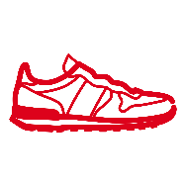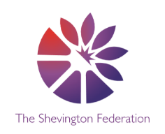

ART

**Activism: Drawing, Paper, Pen & Paint**

* See how artists use their skills to make art which speaks about things that matter, often on behalf of whole communities.
* Create visuals and text which communicate the things that I care about.
* Use line, shape and colour to make my artwork.
* Use typography to make my messages stand out.
* Combine different techniques such as print, collage and drawing.

PSHE

**Economic wellbeing.**

**Safety and the Changing body.**

MUSIC

* **Song Writing**
* **Ukuleles**

**Creative Multiple perspectives Justify Debate Cause + Consequence Share a Story Make Connections Wider World Economise**

PE

**Athletics**

* Athletics
* Striking & Fielding
* Outdoors Adventure

RE

**Can religions help build a fairer world? Students will:**

* Explore different religions and look at why they want a fairer world.
* Determine what is fair and unfair in their own lives and other people’s.

**Who has made a difference because of their beliefs? Students will:**

* Enquire into the lives and work of people who have made a difference because of their beliefs – Mother Teresa.

We will also be looking more in-depth at the holy festival of Diwali – the festival of lights!

MATHS

**Throughout the summer term, we will be covering the following areas:**

* Position & Direction
* Statistic
* Geometry
* Enterprise

O

LEVEL

G

LEVEL

M

LEVEL