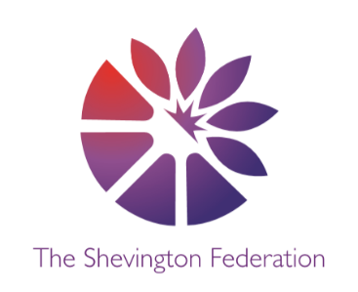

















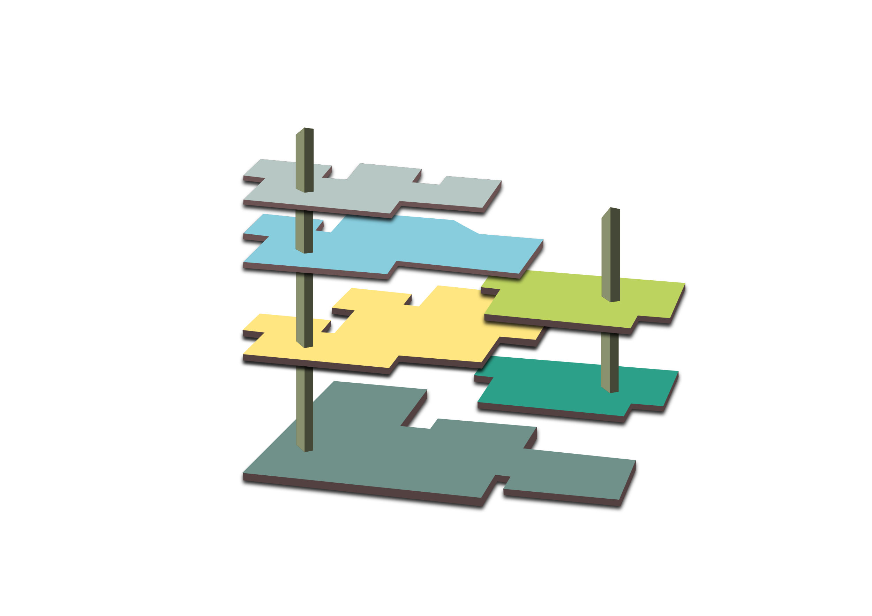
014
THE LOBBY

The Gift Shop (Trips & Enrichment)
- Jodrell Bank
- Beeston Castle/Local Visit (St Ann’s)
- London Residential
- Local Field Work

LEVEL 2

Global Connections (MFL - Spanish)
- Universe
- Food
- Around the Town

The Library (Class Readers)
- Nowhere Emporium/See You In The Cosmos
- Varjak Paw/Boy 87
- No Ballet Shoes in Syria/The Queen’s Token

Philosophical Exhibit (Extended Writing)
- Does exploration and discovery always benefit humanity?
- How does the past influence modern society?
- What defines your culture?
LEVEL 3

Around the World (Geography)
- South America (Locational Knowledge)/Biomes
- Regions of the UK and European Cities
- Local Fieldwork

Artefact Collections (History)
- The Maya Civilisation
- Anglo-Saxons and Viking Britain
- Medieval Monarchs

Significant People (Past & Present)
- Louise Fili/David Attenborough
- Holocaust Focus/Alfred the Great
- Zaha Hadid

Year 5: Museum of Long-Term Knowledge
GROUND LEVEL

The Reflection Room (RE)
- Christianity / Islam
- Hindu Dharma / Christianity
- Christianity / Judaism

The Room of Wellbeing (PSHCE)
- Families and Relationships/Health and Wellbeing
- Economic Wellbeing
- Citizenship/Safety and the Changing Body
M
3
2
G
O
OUTSIDE

The Garden (Outdoor Opportunities)
- Local Fieldwork activities throughout the year

Active Space (PE)
- Gymnastics and Invasion Games
- Net and Wall and Invasion Games
- Athletics and Striking and Fielding
1

LEVEL 1

The Research Lab (Science)
- Earth and Space/ Forces
- Properties of Materials
- Living Things and Their Habitats/Animals Including Humans

Meet the Maker (DT)
- Mechanical Systems
- Healthy Food
- Structures - Bridges

Technology Expo (Computing)
- Programming A
- Creating Media – Video Production and Vector Graphics
- Programming B/Databases
MEZZANINE

The Music Lounge (Music)
- Create and Sing (Opera)
- Mars – Holst BBC Ten Pieces
- Ukulele

The Gallery (Art)
- Typography and Maps
- Fashion Design
- 3D Architecture
L

