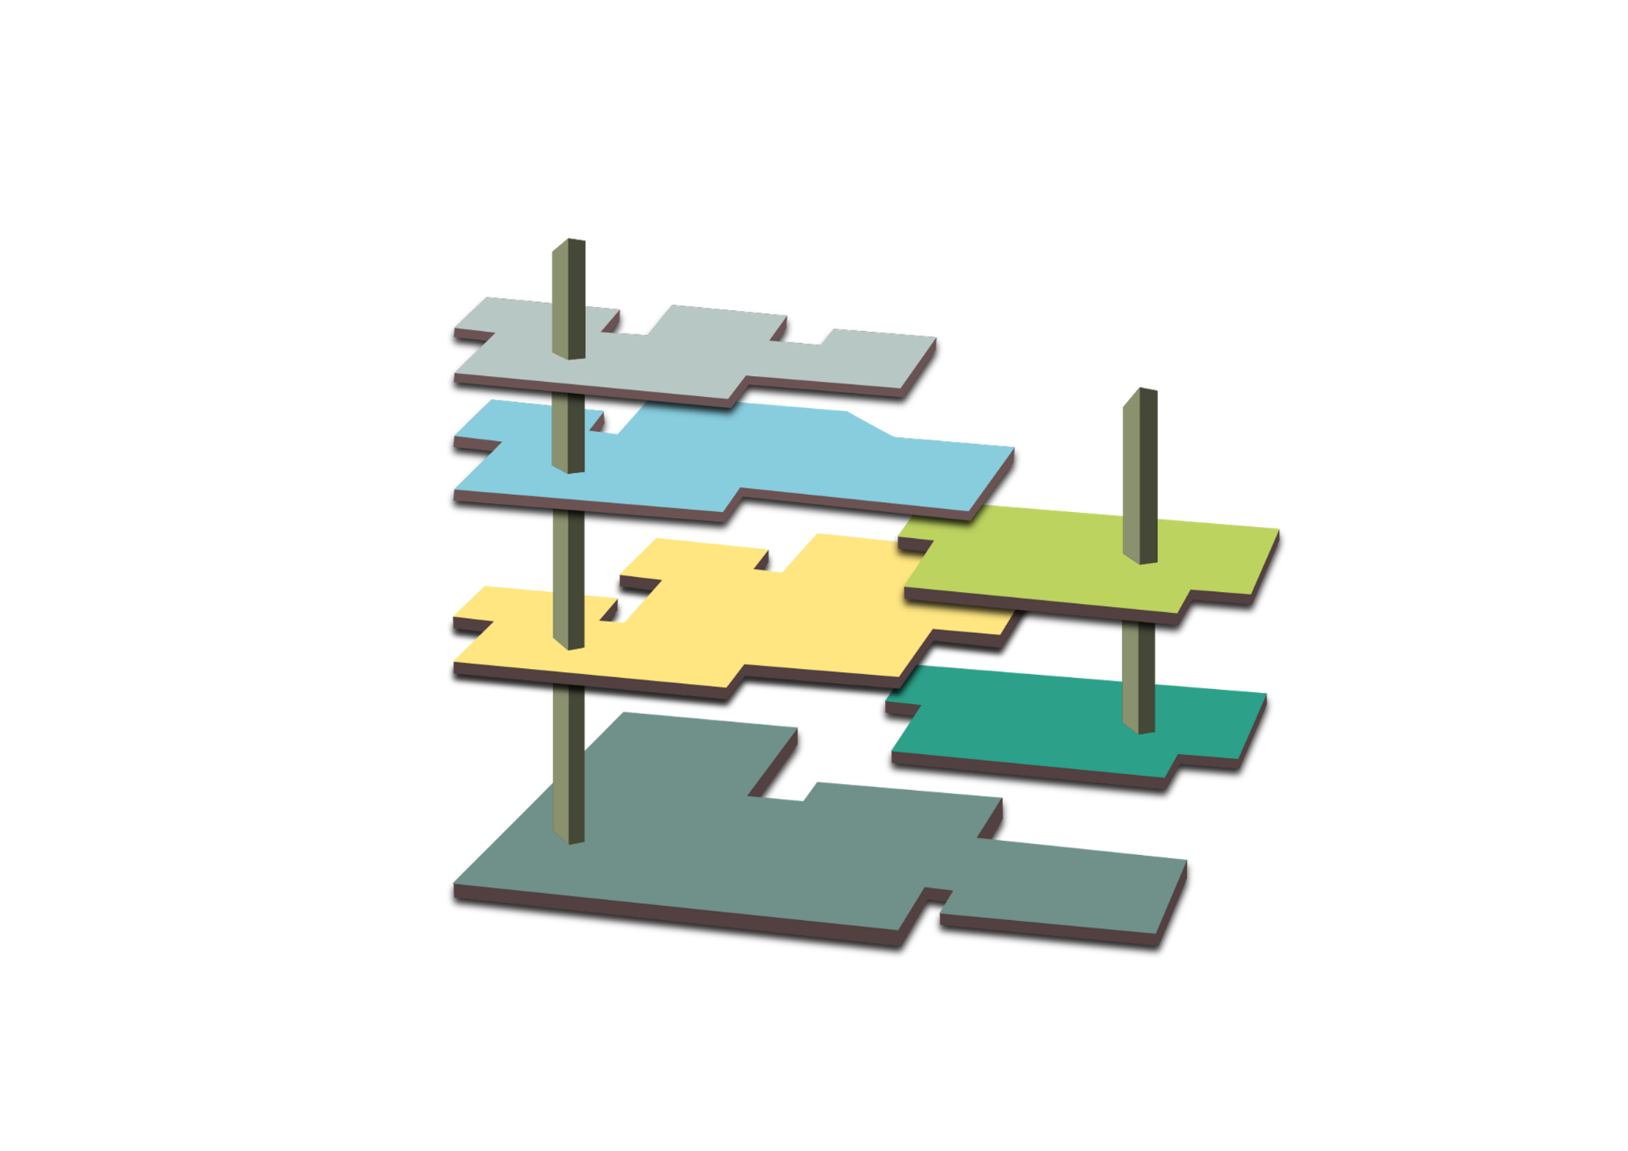

















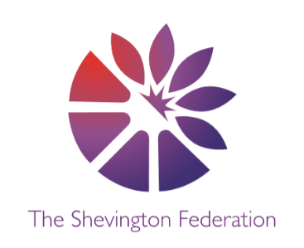
OUTSIDE

The Garden (Outdoor Opportunities)
- Local woodland & countryside, school fields

Active Space (PE)
- Gymnastics & Dance: Sequences/ Invasion Games: Tactics
- Invasion Games: Skills & accuracy/Net & Wall Games
- Athletics/Striking & Fielding
LEVEL 3

Around the World (Geography)
- Coastlines, Energy & Sustainability
- Population/ Digimaps: Urbanisation
- Globalisation

Artefact Collections (History)
- The Victorians & The Industrial Revolution
- 20th Century Conflict WW2
- The Civil Rights Movement

Significant People (Past & Present)
- Charles Darwin/Mary Anning
- Winston Churchill/Arctic Convoys
- Harriet Tubman/Martin Luther King

Year 6: Museum of Long-Term Knowledge
LEVEL 2

Global Connections (MFL)
- Daily Routine
- Days Out
- Careers

The Library (Class Readers)
- Kensuke’s Kingdom/On the Origin of the Species/Kensuke’s Kingdom
- When the Sky Falls
- Holes/Can you see me?

Philosophical Exhibit (Extended Writing)
- Has the Industrial Revolution have a positive effect on the planet?
- Will we ever see world peace?
- Restaurant planning & evaluation
LEVEL 1

The Research Lab (Science)
- Light/Evolution & Inheritance
- Electricity
- Living Things & Their Habitats/Animals including Humans

Meet the Maker (DT)
- Digital World: Navigating the World
- Electrical Systems: Steady Hand Game
- Cooking and Nutrition: Come Dine with Me

Technology Expo (Computing)
- The Internet
- Creating Media: Webpage Creation
- Mambo - Rhythm & Pulse/Musical Theatre

GROUND LEVEL

The Reflection Room (RE)
- Christianity (God)/Hindu Dharma
- Islam/Christianity (Jesus)
- Buddhism/Christianity (Church)

The Room of Wellbeing (PSHE)
- Families & Relationships/Health & Wellbeing
- Citizenship
- Economic Wellbeing/Safety & the changing body
MEZZANINE

The Music Lounge (Music)
- Ukulele - Blues & Improvising/Composition: Song Writing
- Film Music/Ride of the Valkyries
- Mambo - Rhythm & Pulse/Musical Theatre

The Gallery (Art)
- 2D – 3D: Scale & Sculptures
- Exploring Identity: Drawing, Collage & Sketchbooks
- Print and Activism: Paper, Pen & Paint
THE LOBBY

The Gift Shop (Trips & Enrichment)
- Formby Beach/Panto/Cinema
- Local Area
- Residential/International Slavery Museum

3
2
M
L
1

O
G

